37. A medical supply provider manufactures disposable N95 respirator masks and packages them into air-sealed boxes, with each box containing 200 individual masks. Once a week, the company produces the masks and distributes them to several regional hospitals. The company also produces other types of masks and medical supplies that require the same resources. As a result, its production capacity for the N95 masks varies from week to week. The accompanying frequency distribution shows the weekly N95 mask production capacity from the previous 50 weeks.
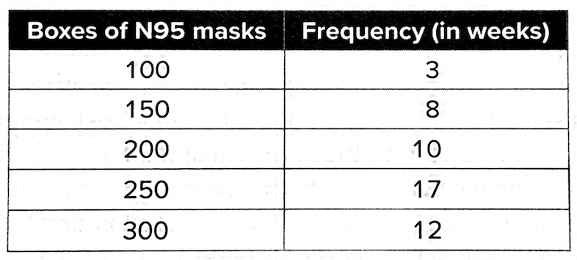
During a pandemic, the company has difficulties predicting the demand for the N95 masks and can only speculate that, at minimum, the hospitals will need 170 boxes of the masks on a weekly basis. After consulting with the local public health officials, the company believes that the hospitals will not require more than 400 boxes of N95 masks per week, and the most likely demand would be about 200 boxes each week, according to Triangular distribution.

- (Using Python or Excel) With a seed of 1, to develop a Monte Carlo simulation with 500 trials. What are the mean and standard deviation of the demand and production capacity?
- Based on the simulation, what is the probability that the company cannot produce enough N95 masks to support the regional hospitals?
- Based on the simulation, what is the probability that the company will have an excess production capacity?

Note:
For the N95 Demand, max = 400, min = 170, and mode = 200.

For Python, use the function:
# Generate random samples using triangular distribution
Demand = np.random.triangular(left=min_value, mode=mode_value, right=max_value, size=num_trials)

For Excel, use the hard code for the triangular distribution:

=IF(value<(mode-min)/(max-min),
min + SQRT(value*(max-min)*(mode-min)),
max - SQRT((1-value)*(maxx-min)*(max-mode)))

